Day 29

Java throw Exception
In Java, exceptions allows us to write good quality codes where the errors are checked at the compile time instead of runtime and we can create custom exceptions making the code recovery and debugging easier.

Java throw keyword
The Java throw keyword is used to throw an exception explicitly.
We specify the exception object which is to be thrown. The Exception has some message with it that provides the error description. These exceptions may be related to user inputs, server, etc.
We can throw either checked or unchecked exceptions in Java by throw keyword. It is mainly used to throw a custom exception. We will discuss custom exceptions later in this section.
We can also define our own set of conditions and throw an exception explicitly using throw keyword. For example, we can throw ArithmeticException if we divide a number by another number. Here, we just need to set the condition and throw exception using throw keyword.
The syntax of the Java throw keyword is given below.
throw Instance i.e.,
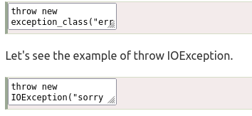

Where the Instance must be of type Throwable or subclass of Throwable. For example, Exception is the sub class of Throwable and the user-defined exceptions usually extend the Exception class.

Java throw keyword Example

Example 1: Throwing Unchecked Exception
In this example, we have created a method named validate() that accepts an integer as a parameter. If the age is less than 18, we are throwing the ArithmeticException otherwise print a message welcome to vote.
TestThrow1.java
In this example, we have created the validate method that takes integer value as a parameter. If the age is less than 18, we are throwing the ArithmeticException otherwise print a message welcome to vote.

public class TestThrow1 {
//function to check if person is eligible to vote or not
public static void validate(int age) {
if(age<18) {
//throw Arithmetic exception if not eligible to vote
throw new ArithmeticException("Person is not eligible to vote");
}
else {
System.out.println("Person is eligible to vote!!");
}
}
//main method
public static void main(String args[]){
//calling the function
validate(13);
System.out.println("rest of the code...");
}
}

Output:

The above code throw an unchecked exception. Similarly, we can also throw unchecked and user defined exceptions.

Note: If we throw unchecked exception from a method, it is must to handle the exception or declare in throws clause.
If we throw a checked exception using throw keyword, it is must to handle the exception using catch block or the method must declare it using throws declaration.

Example 2: Throwing Checked Exception

Note: Every subclass of Error and RuntimeException is an unchecked exception in Java. A checked exception is everything else under the Throwable class.
TestThrow2.java

import java.io.*;

public class TestThrow2 {

//function to check if person is eligible to vote or not
public static void method() throws FileNotFoundException {

FileReader file = new FileReader("C:\\Users\\Anurati\\Desktop\\abc.txt");
BufferedReader fileInput = new BufferedReader(file);

throw new FileNotFoundException();

}
//main method
public static void main(String args[]){
try
{
method();
}
catch (FileNotFoundException e)
{
e.printStackTrace();
}
System.out.println("rest of the code...");
}
}

Example 3: Throwing User-defined Exception
exception is everything else under the Throwable class.
TestThrow3.java
// class represents user-defined exception
class UserDefinedException extends Exception
{
public UserDefinedException(String str)
{
// Calling constructor of parent Exception
super(str);
}
}
// Class that uses above MyException
public class TestThrow3
{
public static void main(String args[])
{
try
{
// throw an object of user defined exception
throw new UserDefinedException("This is user-defined exception");
}
catch (UserDefinedException ude)
{
System.out.println("Caught the exception");
// Print the message from MyException object
System.out.println(ude.getMessage());
}
}
}

Java Exception Propagation
An exception is first thrown from the top of the stack and if it is not caught, it drops down the call stack to the previous method. If not caught there, the exception again drops down to the previous method, and so on until they are caught or until they reach the very bottom of the call stack. This is called exception propagation.

Note: By default Unchecked Exceptions are forwarded in calling chain (propagated).

Exception Propagation Example
TestExceptionPropagation1.java

class TestExceptionPropagation1{
void m(){
int data=50/0;
}
void n(){
m();
}
void p(){
try{
n();
}catch(Exception e){System.out.println("exception handled");}
}
public static void main(String args[]){
TestExceptionPropagation1 obj=new TestExceptionPropagation1();
obj.p();
System.out.println("normal flow...");
}
}

In the above example exception occurs in the m() method where it is not handled, so it is propagated to the previous n() method where it is not handled, again it is propagated to the p() method where exception is handled.
Exception can be handled in any method in call stack either in the main() method, p() method, n() method or m() method.

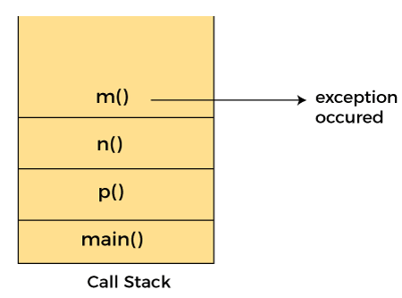

Note: By default, Checked Exceptions are not forwarded in calling chain (propagated).

Exception Propagation Example
TestExceptionPropagation1.java
class TestExceptionPropagation2{
void m(){
throw new java.io.IOException("device error");//checked exception
}
void n(){
m();
}
void p(){
try{
n();
}catch(Exception e){System.out.println("exception handeled");}
}
public static void main(String args[]){
TestExceptionPropagation2 obj=new TestExceptionPropagation2();
obj.p();
System.out.println("normal flow");
}
}

